Boulder Ridge Wild Animal Park Seasonal Work Position
Park Attendant

Classification: Seasonal work position with hours available starting April 1st through Mid October. Staff hired prior to zoo opening April 1st will have training occur in March. Staff hired after zoo has opened for the season will receive on-the-job training amongst fellow staff.

Wage: Will be discussed at time of interview, no overtime or holiday pay

Shift Schedule: Staff will work shifts around school hours (if applicable). Part-time or full-time opportunities options based on applicants’ availability. Scheduled shifts can start as early as 8 AM, afternoon shifts can go as late as 6:30 PM, or later if evening zoo rentals are reserved. Applicants must be available to work weekends and holidays. Any known vacation or time-off requests must be brought to the attention of Boulder Ridge managers in the applicant’s interview.

Job Description:
Park Attendants are a vital role at Boulder Ridge Wild Animal Park. It is dynamic position that fills many roles such as customer service with facilitating the popular feed stations and educating zoo visitors about our animal collection. As well as maintaining the aesthetic view of the park for guests. Applicants must have a good work ethic and people skills as you are impacting zoo guests experiences daily.

Job roles include, but are not limited to:
- Operation of the 2 feed stations, which includes cash handling at a register.
- Prepping animal feed for sale at the stations (carrots and lettuce).
- Operating the popular train ride for children when tickets are purchased.
- Interacting with the public, answering questions, maintaining safety of animal collection as zoo guests have direct interactions (this includes parakeets, llamas, goats, camels, giraffes, etc)
- Maintaining zoo cleanliness by picking up trash in zoo and parking lot, emptying trash cans, wiping down picnic tables, cleaning public restrooms at closing.
- Maintaining the zoo’s expansive horticulture displays through weeding and watering plantings.
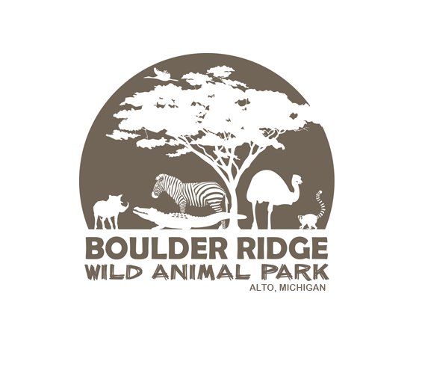
- Select Park Attendant staff who have a positive background experience working with children, and have shown great job performance at Boulder Ridge, will be chosen to work the new Zoo Camp for a select amount of time during the summer months.

