Boulder Ridge Wild Animal Park Seasonal Work Position
Concessions

Classification: Seasonal work position with hours available starting April 1st through mid October. Staff hired prior to zoo opening April 1st will have training occur in March. Staff hired after zoo has opened for the season will receive on-the-job training amongst fellow staff.

Wage: Will be discussed at time of interview, no overtime or holiday pay

Shift Schedule: Staff will work shifts around school hours (if applicable). Part-time or full-time opportunities options based on applicants’ availability. Scheduled shifts can start as early as 10:00 AM, afternoon shifts can go as late as 6:30 PM, or later if evening zoo rentals are reserved. Applicants must be available to work weekends and holidays. Any known vacation or time-off requests must be brought to the attention of Boulder Ridge managers in the applicant’s interview.

Job Description:
Concessions staff are a vital role at Boulder Ridge Wild Animal Park. It is position that can fill several roles. Roles can include providing great customer service with facilitating the sale of concession food, answering general zoo questions, as well as maintaining the aesthetic view of the concessions & picnic areas for guests. Staff in concessions area main focus will be food preparation and delivery for guests in a safe but timely manner. All concessions staff will be required to abide by all Health Code standards of uniform attire and personal hygiene. Applicants must have a good work ethic and people skills as you are impacting zoo guests experiences daily.

Job roles include, but are not limited to:
- Operation of the concession area, which includes cash & card handling at a register, food preparation, and serving food to guests.
- Cleaning cooking equipment, utensils, and dishes.
- Refilling dispensers of items used by guests including napkins, condiments, etc.
- Interacting with the public, answering questions, maintaining a positive environment for guests.
- Facilitate a safe and organized space for all guests when large groups, especially school groups, are in the concessions area.
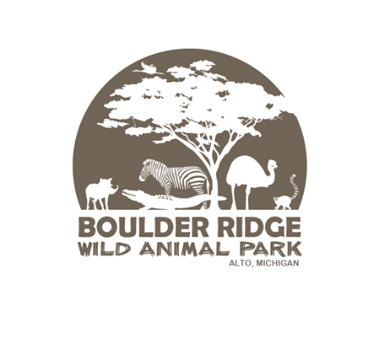
- Maintaining zoo cleanliness by picking up trash near or within concessions building, and picnic areas. Notifying park attendant staff when trash containers are becoming full and need emptying.

